MEMRACE: Adaptive Learning Platform
Dr P Veera Prakash¹, S Madhuri^{2b}, K Vishnu Sai^{2c} and I Chandra Sekhar^{2d}
¹Assistant Professor, Srinivasa Ramanujan Institute of Technology
²Student, Srinivasa Ramanujan Institute of Technology Computing
Anantapur, Andhra Pradesh, 515001, India
Prakash.cse@srit.ac.in, 224g1a0543@srit.ac.in, 224g1a05c4@srit.ac.in, 224g1a05c1@srit.ac.in
Keywords: Adaptive Learning, Artificial Intelligence, SuperMemo-2 Algorithm, AI Based Content Generation, Natural Language Processing, Personalized Learning, Learning Analytics, Spaced Repetition, Flashcard Generation, Performance Dashboards.
Abstract: Keeping track of academic material be a major challenge in present learning environments. Learners rely on unsteady revision habits, and educators face difficulty as they can’t exactly build custom quizzes for every single learner. As a result, MEMRACE the Adaptive learning platform is introduced that improve knowledge preservation by spaced repetition algorithm and AI driven content creation. MEMRACE allows learners to upload study materials, text or documents and these are used to extract the relevant content for learning. AI builds structured flashcards and quizzes based on the extracted content that enhances active recall and self-assessment. In order to maintain sustained memory, the platform embeds spaced repetition approach using SuperMemo-2 algorithm which schedules the repetition of questions at certain intervals based on the user performance scores and feedback. Learning progress, accuracy of review repetition history are recorded. Based on these analytics, personalized learning recommendations are provided that states on which topics user focus more. The platform is presented as a web-based application. The proposed system shows how intelligent scheduling and adaptive feedback can help efficient learning and knowledge retention, and can be used in self-directed learning environments as well as technology assisted education systems.

Introduction
The explosion in the growth of digital education platforms has revolutionized the way in which learners’ The explosion in the growth of digital education platforms has revolutionized the way in which learners’ access and consume educational content. While online learning environments have the advantages of flexibility and broad access to resources, they frequently are based on static learning structures that fail to accommodate the needs of individual learners. Such systems tend to offer the same content and revision timetables to all users which can result in inefficient learning, poor long-term retention of information and cognitive overload. As learning outcomes are closely linked with the memory and effective revision strategies, there is a rising demand for Adaptive learning systems that can make the study processes personalised by considering the learner behaviour and performance.
Cognitive psychology research emphasizes the importance of memory retention for learning and suggests that learning is better retained with active recall and spaced repetition instead of reading the same material again and again. Spaced repetition techniques are techniques where reviews are scheduled at intervals that increase over their lifetime, so that learners can review information at the optimal time before they forget it. However, many existing educational platforms either fail to implement strategies or use them in a fixed way without taking into account individual performance variations. But recent advances in artificial intelligence have made it possible to automate the processing of content and personalization in educational systems. Natural language processing and generative models can take unstructured learning materials and turn them into structured learning materials such as flashcards and assessment questions. When combined with learner analytics, these techniques enable systems to be tailored in terms of content difficulty, frequency of revision and areas of focus. Despite this potential, the use of AI-powered content generation in combination with scientifically-proven memory models is limited in practical ways for learning. To overcome these obstacles, this work proposes a novel approach to design a Adaptive learning platform, namely, through integrating AI-assisted content generation and adaptive spaced repetition to improve learning efficiency and knowledge retention, called MEMRACE. The system is used to upload learning materials to the system, which is processed to extract the relevant textual contents. An AI-based module takes this content and turns it into flashcards and quiz questions to encourage active recall and self-assessment. The platform uses the SuperMemo-2 algorithm to automatically space the interval of review time based on user feedback and performance, providing for personalized cycles of revision.
In addition, MEMRACE also features learning analytics to track user interactions such as accuracy in review and quiz results. These analytics are used to make personalized recommendations to assist learners in identifying weak areas and plan the targeted revision strategies.

LITERATURE REVIEW
The incorporation of artificial intelligence in education has seen huge leaps being made in adaptive learning systems, with the goal of personalizing instruction, boosting engagement and maximizing long-term knowledge retention. Recent studies focus especially on the fact that traditional learning methods and approaches of one-size-fits-all learning are increasingly unable to meet the needs of learners and play a determining role in the development of artificial intelligence based adaptive platforms. (Alshammari, 2025) investigates ChatGPT-enhanced adaptive e-learning systems and provides evidence of how conversational AI can support personalised explanation, adaptive feedback and interaction with the learner. The study brings up the potential of large language models to improve learning adaptability while also pointing to challenges of pedagogical alignment and content reliability.
The deployment of adaptive learning systems in context has been investigated in difficult educational environments. (Qahman et al., 2025) examine the adoption of artificial intelligence enabled adaptive e-learning systems in Palestinian schools located in conflict zones. Their findings suggest the continuity of learning and the possibility of personalization of learning, in spite of infrastructural and environmental constraints, may be maintained by adaptive systems. This work highlights the role of resilience and contextual sensitivity in adaptive learning design. Extending the discussion to the topic of sustainability, (Strielkowski et al., 2025) discuss using AI-driven adaptive learning as a mechanism for sustainable educational transformation, thereby arguing that such systems can support inclusive and sustainable long-term educational development when combined with institutional strategies.
Domain-specific adaptive learning applications are another example of how effective AI personalization is. (Ma, Tang, Huang, 2025) are focus on the AI-powered adaptive English language learning systems using deep learning and natural language processing techniques. Their study shows that the sequencing of personalized content with adaptive feedback is extremely beneficial in improving learner outcomes. Although (Zheng et al., 2025) work on adaptive federated learning in supply chains, their work provides relevant information for understanding adaptive information-sharing architectures, which can be used to inform privacy-aware and decentralized educational platforms.
Cognitive and psychological aspects of adaptive learning are very well studied. (Ahmed and Abdullah, 2025) analyse the effects of adaptive AI learning systems on cognitive load and academic persistence and conclude that adaptive mechanisms have the potential to alleviate unnecessary cognitive burden and enhance learner motivation and persistence. (Saleem et al., 2025) go on to analyse personalized learning systems further and say that positive effects were shown on student performance and engagement, focusing on individualized feedback and pacing. These findings add support for the value of making adaptive systems conform to cognitive load theory.
Advanced adaptive modelling approaches have also been suggested. (Zhou et al., 2025) present a complementary spatiotemporal learning system for data adaptive model evolution and show the importance of continuous adaptation on the evolving data pattern. While their work is located in the field of pattern analysis, the notion of evolving models has implications with respect to adaptive learning system which is adapted according to learner interaction. (Hussain et al., 2025) more specifically focuses on cognitive load management with adaptive AI learning systems, and there are improvements in student focus and retention when guided by learner performance-based data for adaptation.
Pedagogical integration is still a major research topic. (Katona and Gyonyoro, 2025) examine the blend of AI-based adaptive learning with the flipped classroom model and find higher engagement and better learning outcomes. (Isaeva et al., 2025) discuss the application of adaptive learning platforms with the use of emerging computer technologies and have concluded that their integration enhances learning effectiveness at various levels of education. These studies indicate that the most successful use of adaptive learning systems is when the system is integrated into instructional models, rather than used by itself.
Several systematic reviews can be found that summarize the research on adaptive education. (Hariyanto et al., 2025) present a systematic review of artificial intelligence techniques used in adaptive education, finding that the machine learning, rule-based systems and learning analytics are the dominant methods. The authors also point out challenges concerning scalability, data quality and system interpretability. (Yaseen et al., 2025) explore the effect of technology-based learning tools (i.e., adaptive learning technologies and interactive AI tools) on students engagement and the findings show that digital literacy has an important moderating effect on learning outcomes, which means the effectiveness of adaptive platforms depends on the readiness of learners.
Ethical and evaluation issues are becoming a focus of the adaptive learning research. (Leong and Zhang, 2025) discuss principles of ethical design of AI in education, which include transparency, fairness, accountability and learner autonomy. (Bolsinova et al., 2025) judge adaptive learning systems according to Elo ratings and note the need for reliable measurement models in order to guarantee valid learner assessment. It is these studies that highlight the importance of responsible and trustworthy adaptive system design.
Human cantered approaches are an emerging topic in the past few years. (Tarun et al., 2025) discuss human-in-the-loop adaptive learning systems which integrate generative AI and educator oversight. Their findings suggest that it is possible to enhance the reliability and pedagogical quality of personalization using AI, with human supervision. (Yvonne Khomo et al., 2025) review adaptive learning management systems based on personalized approaches and bioinspired algorithms, which suggest an improvement of the adaptability and robustness of the system. (Chen et al., 2025) propose the design and implementation of an educational chatbot based on personalized adaptive features, which shows its effectiveness in a professional training.
Knowledge retention and engagement is a big theme of adaptive learning research. (Shanthi et al., 2025) propose an AI-driven adaptive IT training framework which focuses on personalized learning paths for better retention and engagement. (Kolomoiets et al., 2025) present adaptive learning systems which rely on biometric assessment of cognitive load and illustrate the use of physiological indicators for a personalization strategy. (Das et al., 2025) talk about adaptive education as a transformative approach, especially in the field of inclusive education and disability support, and the role of AI in addressing different learner needs.
Psychological mechanisms for the effectiveness of adaptive learning (Ouyang, 2025) analyses the self-regulated learning and engagement as mediating factors between the characteristics of the adaptive platform and the quality of education. (Pelalnek, 2025) offers an important critical commentary on adaptive learning, addressing the difficulties, subtleties and trade-offs associated with modelling learner behaviour and personalization. (Olson et al. 2025) have presented a platform for adaptive experimentation that provides methodological insight for optimizing adaptive systems through systematic experimentation.
Overall, the literature shows that AI-driven adaptive learning systems have great potential for improving personalization, engagement and retention when based on cognitive theory and ethical design principles. However, challenges in the areas of model complexity, evaluation, learner diversity and deployment in the field of learning remain open, which serves as a motivation for ongoing research into structured and scientifically grounded Adaptive learning platforms.

SYSTEM ARCHITECTURE
This section explains the proposed methodology of MEMRACE Adaptive learning platform. The methodology will be tailored to address the individualized learning, enhance a long-term retention of knowledge and flex learning schedules depending on the individual performance of learners. The system combines AI processing of content, adaptive learning algorithms, and learning analytics in a modular web-based system. The entire process has a systematic pipeline that includes the acquisition of content, personal recommendations, and adaptive revision timetable.

Overall system architecture of the MEMRACE Adaptive learning platform showing the interaction between user interface, AI-based content generation, adaptive learning engine, analytics, recommendation module and database.

All the user data, generated content and performance records of are securely stored, managed in the database.
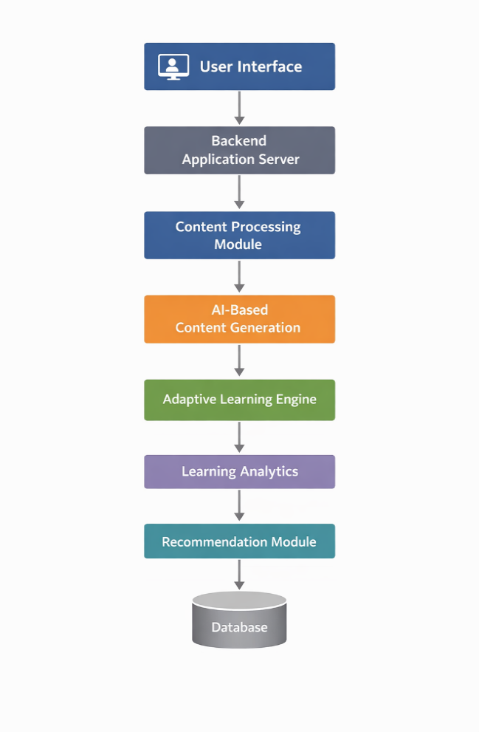
Figure 1 System Architecture of MEMRACE
The suggested system is based on a client-server model that is a web-based platform of learning. The frontend is used to offer user interfaces on content upload, flashcard review, quiz interaction and performance visualization. A modular server architecture is used to implement the backend and makes application programming interfaces available to authentication, content processing, learning management, analytics and recommendations. All functional components are isolated into autonomous modules in order to support scalability and maintainability. The user profiles, learning content, history of interactions and performance metrics are stored by a central database. The architecture is also extensible, that is, it can be extended by the addition of other learning models or analytics elements without redesigning the core system.

Content Processing module takes raw uploaded files and extracts the text in structured format. AI Content Generation module creates flashcards and quizzes based on the extracted text. Adaptive Learning Engine module uses space repetition mechanism that include SM-2 algorithm for repetition of questions. Analytics Module Tracks learner performance, review history, and interaction patterns. Recommendation Module Generates personalized study suggestions based on learning analytics.

PROPOSED METHODOLOGY
The MEMRACE system development and assessment process uses a systematic approach that operates in multiple stages while combining educational research methods with system engineering techniques and AI development based on data analysis. The methodology guarantees that the platform maintains educational effectiveness while achieving technical growth and receiving scientific proof of its effectiveness.

Requirement Analysis
The methodology's first stage dedicated its efforts to discovering all system requirements through a methodical assessment procedure which uncovered both functional and non-functional needs. The research involved an extensive examination of current Learning Management Systems and ERP-connected educational systems to discover existing challenges in personalization and operational system compatibility. According to previous studies adaptive learning environments must provide personalized learning paths together with instant feedback delivery and digital systems that can expand their operational capacity.
The educational policies and digital learning standards were analysed to verify their compliance with institutional standards and their ethical use of artificial intelligence in educational settings. The analysis of multiple sources identified essential system requirements which included adaptive learning features alongside intelligent assessment systems and real-time monitoring capabilities and ERP system compatibility and system growth potential and comprehensive data protection measures.

System Design
The system design process began after the platform requirements had been officially established through the identification of functional deficiencies found in Anki Droid and Kahoot learning tools which needed to support both long-term retention and active user participation. Studies show that students achieve better educational outcomes when they use interactive learning environments that integrate adaptive intelligence because this method provides personalized learning experiences and increases student engagement. The research findings resulted in a modular architecture design which is used to create the system.

Learning Contents and Processing
The content acquisition stage of the methodology
is aimed at learning. The users will be enabled to post study materials in text or document formats like portable document files. The uploaded documents are subjected to a content extraction module used to identify and extract the information regarding the text. Text cleaning, extraction of other non-informative symbols, and content synthesis into manageable learning units are some of the preprocessing steps. This guarantees that the information fed into other modules is arranged and can be automated to be processed. With the self-directed learning it provides, the system allows direct content uploading in a variety of subjects and domains without depending on the predefined datasets.

Content Generation of AI
Once it is pre-processed, the learning material is extracted and handed to an AI-driven content generation module. It is a module that is based on a generative language model that is capable of converting unstructured text into structured elements of learning. The outputs that have been produced are flashcards with question-answer pairs and quiz questions aimed at testing the understanding. Timely design is taken to guarantee that the content created does not drift out of the original content or present foreign and unrelated content. The flashcards developed by AI facilitate active recall and quizzes allow making a formative assessment. This automated content generation saves on man power as well as enabling quick transformation of huge study materials into interactive learning materials.

Spaced Repetition Mechanism and Adaptive Learning
To make improvement in the retention of information, the system incorporates a modifiable strategy of learning which relies on the principle of spaced repetition. The algorithm used as a methodology is SuperMemo-2 that allows scheduling the time interval during which each flashcard must be viewed. The algorithm takes into account the feedback of the learners following each reviewing session in terms of the accuracy of the recollection and the perceived difficulty.
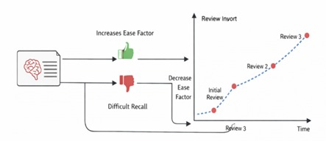
Figure 2: Adaptive spaced repetition mechanism illustrating how learner recall performance and feedback dynamically adjust review intervals and ease factors over successive learning sessions.
The system responds to this feedback and is dynamically adjusted to change the repetition interval and ease factor of an item to be learned. The difficult items will be reviewed with a higher frequency than the well-mastered items that will be reviewed with a longer time interval. This dynamic planning guarantees the effective utilization of the study time and facilitates the long-term memory by strengthening the information during the most favourable times.

Learning Analytics and Performance Tracking
The system keeps tracking the interaction between the learners to facilitate the adaptation of data. These performance metrics are accuracy of flashcard recall, good marks in a quiz, number of reviews and temporal advancement. These metrics are registered in the database and processed after analysis with the help of an analytics module. The analysis is able to establish trends in the form of improvement rates, study behaviour consistency, and variations in topic performance. Following the specifics of the interaction, the system obtains the understanding of the learning trends of individual learners. This data is the basis of personalization and evidence-based learning advice.

Recommendation Generation at a Personal Level
The system creates customized recommendations to direct the learners based on the learning analytics. The recommendation module is used to analyse the performance data to determine weak areas, strong topics and inconsistent study behaviour. It will then give practical recommendations like giving priority to certain issues, giving more reviews or doing more quizzes. The recommendations are given in a clear and concise format that will not result in cognitive overburden on the learner. This feedback loop gives the learner a chance to modify his or her learning strategies and continue learning at the same rate.

Workflow and System Integration
The entire procedure incorporates all the modules into unified working process. Once the users are authenticated, they submit content which is then worked with and turned into flashcards and quizzes. Adaptive scheduling directs learning sessions and analytics controls the performance continuously. Dynamic recommendations are made based on the recent interactions. The modular integration is also important in order to guarantee the seamless data flow between component, and also enable the system to react to the learner behaviour in real time. It is an end-to-end workflow that facilitates efficient adaptive and personalized learning.
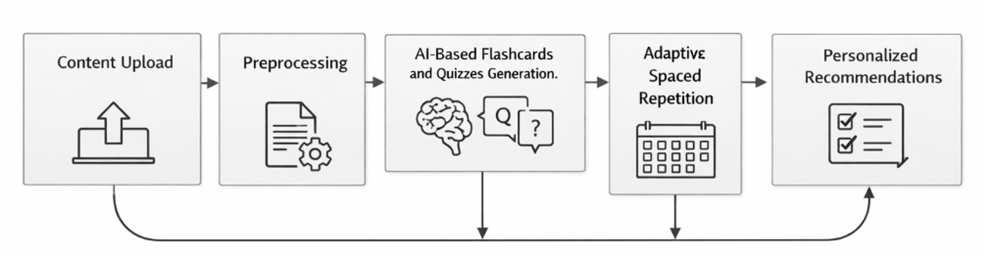
Figure 3: Workflow of the Proposed MEMRACE Platform
The proposed methodology, in general, is a combination of AI-assisted content generation, adaptive spaced repetition, and learning analytics to overcome the weaknesses of conventional learning systems. Relying on personalization based on the data of learners and cognitive principles, the system offers a systematic and scalable way of Adaptive learning.

RESULTS AND DISCUSSION
The evaluation of the proposed MEMRACE Adaptive learning platform is focused on the ability to be used in support of personalized learning, for better knowledge retention and adapt revision schedules according to the individual performance of learners.
System-level observations show that combining AI-based content generation with algorithms for adaptive learning processes helps to efficiently transform uploaded study materials to structured learning resources. Users can create flashcards and quizzes from uploaded documents so spending more time on manually building study materials will be avoided. It uses spaced repetition to review questions for certain intervals based on the performance and feedback. Based on these analytics AI provides suggestions for learning improvements. This helps user to focus on suggested topics, improve memory and performance. The modular architecture provided for stable system operation in repeated cycles of learning and no functional disruptions were observed during the processing of contents or review scheduling or analytics updates. Overall, the results show the proposed methodology to be effective for operationalizing the principles of adaptive learning in a unified platform.
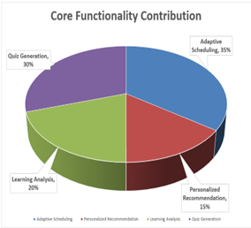
Figure 4: Core Functionality Contribution
In terms of learning effectiveness, the system showed obvious improvements in terms of learner engagement and study consistency. The availability of flashcards generated from AI led to active recall and quizzes led to immediate formative assessment. Analytics showed that learners that regularly interacted with the adaptive review schedule showed progressive improvement in recall accuracy with time. It helps to decrease the repetition of topics that you are strong and enables to focus more on weak topics. This helps for self-assessment and memory retention.mo-2 algorithm schedules repetition of questions by the EF factor calculated based on the user performance. It also provides recommendations based on the analytics generated after completion of quiz. The user can remember the things more efficiently by the repetition mechanism.
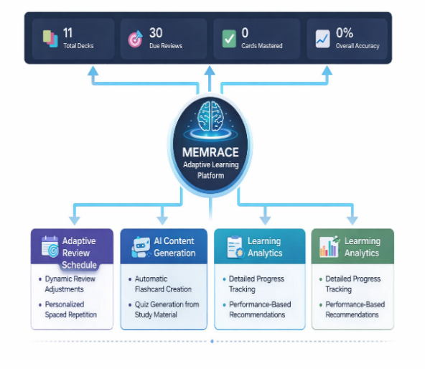
Figure 5: Performance Representation
All the results states that integrating cognitive learning with AI provides increase in self-based learning. The system behaviour is consistent that spaced repetition and active recall of questions improve long term memory retention. By automating the quizzes with AI, it bridges gap between manual creation and automated learning. The proposed MEMRACE platform provides sclable and adaptive learning methods.

REFERENCES
Ahmed, M., & Abdullah, A. (2025). The influence of adaptive AI learning systems on cognitive load and academic persistence. Review of Applied Management and Social Sciences, 8(2), 1057–1072.

Alshammari, M. T. (2025). An investigation into ChatGPT-enhanced adaptive E-learning systems. TEM Journal, 14(1), 503–510.

Bolsinova, M., Gergely, B., & Brinkhuis, M. J. (2025). Keeping Elo alive: Evaluating and improving measurement properties of learning systems based on Elo ratings. British Journal of Mathematical and Statistical Psychology.

Chen, D. L., Aaltonen, K., Lampela, H., & Kujala, J. (2025). The design and implementation of an educational chatbot with personalized adaptive learning features for project management training. Technology, Knowledge and Learning, 30(2), 1047–1072.

Das, S., Mutsuddi, I., & Ray, N. (2025). Artificial intelligence in adaptive education: A transformative approach. In Advancing adaptive education: Technological innovations for disability support (pp. 21–50). IGI Global Scientific Publishing.

Hariyanto, Kristianingsih, F. X. D., & Maharani, R. (2025). Artificial intelligence in adaptive education: A systematic review of techniques for personalized learning. Discover Education, 4(1), 458.

Hussain, S. A., Ayub, F., & Ahmed, N. (2025). Cognitive load management through adaptive AI learning system implications for student focus and retention. The Critical Review of Social Sciences Studies, 3(3), 701–719.

Isaeva, R., Karasartova, N., Dznunusnalieva, K., Mirzoeva, K., & Mokliuk, M. (2025). Enhancing learning effectiveness through adaptive learning platforms and emerging computer technologies in education. Jurnal Ilmiah Ilmu Terapan Universitas Jambi, 9(1), 144–160.

Katona, J., & Gyonyoru, K. I. K. (2025). Integrating AI-based adaptive learning into the flipped classroom model to enhance engagement and learning outcomes. Computers and Education: Artificial Intelligence, 8, 100392.

Kolomoiets, H., Holiiad, I., Tutashynskyi, V., Hrytsenko, L., Holiiad, R., & Rebryna, M. (2025). Adaptive learning based on biometric assessment of cognitive load in an educational and scientific cluster. BRAIN. Broad Research in Artificial Intelligence and Neuroscience, 16(3), 258–270.

Leong, W. Y., & Zhang, J. B. (2025). Ethical design of AI for education and learning systems. ASM Science Journal, 20(1), 1–9.

Ma, Y., Tang, X. J., & Huang, X. (2025). AI-powered adaptive English language learning systems: Leveraging deep learning algorithms and natural language processing for personalized teaching approaches. IEEE Access.

Nozari, H., Szmelter-Jarosz, A., & Weiland, D. (2025). A fuzzy multiobjective sustainable and agile supply chain model based on digital twin and internet of things with adaptive learning under environmental uncertainty. Applied Sciences, 15(19), 10399.

Olson, M., Santorella, E., Tiao, L. C., Cakmak, S., Garrard, M., Daulton, S., ... & Bakshy, E. (2025). Ax: A platform for adaptive experimentation. In AutoML 2025.

Ouyang, Z. (2025). Self-regulated learning and engagement as serial mediators between AI-driven adaptive learning platform characteristics and educational quality: A psychological mechanism analysis. Frontiers in Psychology, 16, 1646469.

Pelánek, R. (2025). Adaptive learning is hard: Challenges, nuances, and trade-offs in modeling. International Journal of Artificial Intelligence in Education, 35(1), 304–329.

Qahman, A. I. A., Dahlan, H. A., Hussin, M., & Al-Zaqeba, M. A. A. (2025). AI enabled adaptive e-learning systems adoption in conflict zone: Case study of Palestinian schools. TEM Journal, 14(1), 789.

Saleem, S., Aziz, M. U., Iqbal, M. J., & Abbas, S. (2025). AI in education: Personalized learning systems and their impact on student performance and engagement. The Critical Review of Social Sciences Studies, 3(1), 2445–2459.
Shanthi, D., Ashok, G., Biswal, C., Udharika, S., Varshini, S., & Sindhu, G. (2025). AI-driven adaptive IT training: A personalized learning framework for enhanced knowledge retention and engagement. Metallurgical and Materials Engineering, 136–145.

Shi, P., & Liu, W. (2025). Adaptive learning oriented higher educational classroom teaching strategies. Scientific Reports, 15(1), 15661.

Strielkowski, W., Grebennikova, V., Lisovskiy, A., Rakhimova, G., & Vasileva, T. (2025). AI-driven adaptive learning for sustainable educational transformation. Sustainable Development, 33(2), 1921–1947.

Tarun, B., Du, H., Kannan, D., & Gehringer, E. F. (2025, November). Human-in-the-loop systems for adaptive learning using generative AI. In 2025 IEEE Frontiers in Education Conference (FIE) (pp. 1–7). IEEE.

Yaseen, H., Mohammad, A. S., Ashal, N., Abusaimeh, H., Ali, A., & Sharabati, A. A. A. (2025). The impact of adaptive learning technologies, personalized feedback, and interactive AI tools on student engagement: The moderating role of digital literacy. Sustainability, 17(3), 1133.

Yvonne Khomo, F. L., Millham, R., & Mustafa, A. (2025). Personalized adaptive learning management system based on bioinspired algorithm: A systematic review. Engineering Innovations, 14, 139–146.

Zheng, G., Ivanov, D., & Brintrup, A. (2025). An adaptive federated learning system for information sharing in supply chains. International Journal of Production Research, 63(11), 3938–3960.

Zhou, Z., Huang, Q., Wang, B., Hou, J., Yang, K., Liang, Y., ... & Wang, Y. (2025). Coms2t: A complementary spatiotemporal learning system for data-adaptive model evolution. IEEE Transactions on Pattern Analysis and Machine Intelligence.

 https://orcid.org/0000-0002-5319-457X

